Mini Project on Modern Web Development
Workshop - 2 (CSE 2192)
(4th Semester)
Submitted by

Name : ARPIT MISHRA
Reg. No. : 2341013205
Branch : CSIT
Semester : 4th
Section : 3A1
Session : 2024-2025
Admission Batch : 2023


DEPARTMENT OF COMPUTER SCIENCE & INFORMATION TECHNOLOGY
Faculty of Engineering and Technology, Institute of Technical Education and Research
SIKSHA ‘O’ ANUSANDHAN (DEEMED TO BE) UNIVERSITY
Bhubaneswar, Odisha, India

OBJECTIVES

1. Develop an interactive and user-friendly platform that allows users to explore, view, and register for a variety of events including conferences, seminars, workshops, concerts, and festive gatherings.
2. Provide a centralized event listing system that supports real-time search and filtering by event title, category, location, and date, improving user navigation and experience.
3. Design a responsive and modern user interface using HTML, CSS (Flexbox/Grid), and media queries to ensure seamless functionality across desktops, tablets, and mobile devices.
4. Enable detailed event pages where users can view comprehensive information such as event schedule, speakers, multimedia content, and register using an intuitive form.
5. Implement secure and validated registration forms with confirmation pages summarizing user details and allowing options like email confirmation or ticket printing.
6. Create a user dashboard that allows registered users to view their upcoming events and manage their registrations effectively.
7. Integrate interactive elements such as countdown timers, smooth scrolling, hover effects, transitions, and a back-to-top button to enhance user engagement.
8. Facilitate user communication through a contact form and display social media links to allow users to connect and share event information easily.
9. Ensure website accessibility and scalability, allowing future enhancements such as admin panels, payment integration, or event hosting features.
10. Promote events effectively through social sharing tools and by showcasing featured and upcoming events on the homepage with attractive visuals and call-to-actions.

PROJECT DESCRIPTION
The Event Registration Website is a dynamic and user-friendly web application designed to streamline the process of discovering, exploring, and registering for various events. These events may include conferences, seminars, workshops, concerts, fests, and festive gatherings. The platform aims to provide a seamless experience for attendees by offering clear, accessible information and easy-to-use registration features.
The homepage introduces users to the platform with an attractive hero banner, a compelling call-to-action, and previews of featured and upcoming events. From there, users can navigate to an Event Listing Page that showcases all available events with essential details such as titles, dates, times, descriptions, and actionable buttons like “View Details” or “Register Now.”
A search and filtering system, implemented using JavaScript and jQuery, allows users to find events based on title, category, location, or date in real-time. Users can click on individual events to visit a Single Event Page, which provides detailed information including the agenda, speakers, location, date and time, images or promotional videos, a countdown timer, and a registration form. The form collects attendee details such as name, email, and ticket type, and validates inputs before confirming the registration.
Upon successful registration, users are directed to a confirmation page summarizing their event and registration details with options to print or receive a confirmation via email. Registered users also have access to a Dashboard Page where they can view and manage their upcoming events.
The site includes a User Registration Page for account creation, a Contact Page with a message form and social media links, and a responsive Navigation Bar for smooth navigation across devices. The footer contains essential links (Terms, Privacy Policy, FAQ) and social media icons for broader reach and engagement.
Visually, the site is designed with modern aesthetics using CSS Flexbox/Grid, hover effects, and smooth transitions. It is fully responsive through media queries, ensuring usability across desktops, tablets, and smartphones. Interactive enhancements such as smooth scrolling, a countdown timer, form validation, and a back-to-top button contribute to a polished user experience.

SRS OF EVENT REGISTRATION
1. Introduction
- Purpose: Build a responsive event registration platform.
- Scope: Allow users to view, search, and register for events, with personalized dashboards.
- Audience: Event attendees, organizers, and admins.

2. Functional Requirements
- Home Page with featured events and CTA.
- Event listing with search and filter.
- Individual event detail pages.
- Registration and confirmation.
- User account management.
- Countdown timers for events.
- Contact form with submission.
- Social media sharing.
- Smooth scrolling, responsive design.
3. Non-Functional Requirements
- Responsiveness: Compatible across desktop, tablet, and mobile.
- Performance: Fast loading; real-time filtering.
- Security: Basic form validation.
- Scalability: Easily expandable to more events or features.
4. User Interface Requirements
- Modern UI with CSS Grid/Flexbox.
- Interactive hover effects, transitions.
- Hamburger navigation on mobile.
- Clean typography and visual hierarchy.
5. Technologies Used
- Frontend: HTML5, CSS3, JavaScript, jQuery
- Interactivity: jQuery for search/filter, smooth scrolling, and form handling.
- Responsive Design: Media queries, Flexbox/Grid.

HARDWARE REQUIREMENTS
For Developers:
- Processor: Minimum Dual-Core 2.0 GHz (Recommended: Quad-Core 2.5+ GHz)
- RAM: Minimum 4 GB (Recommended: 8 GB or more)
- Storage: At least 2 GB free space (SSD preferred)
- Display: 13” screen, 1366x768 resolution or higher
- OS: Windows 10, macOS, or Linux
- Internet: Stable connection for testing and development
For End Users:
- Device: Smartphone, tablet, desktop, or laptop
- Browser: Latest versions of Chrome, Firefox, Safari, or Edge
- Display: Minimum 720p resolution (Recommended: Full HD)
- Internet: Required for accessing the site
SOFTWARE REQUIREMENTS
Frontend Technologies:
- HTML5 – For structuring the web pages
- CSS3 – For styling and responsive layout (Flexbox/Grid, media queries)
- JavaScript – For dynamic behaviour (e.g., form validation, countdown timer)
- jQuery – For simplified DOM manipulation, animations, and event handling
Development Tools:
- Code Editor: Visual Studio Code (or any preferred code editor)
- Web Browsers: Google Chrome, Mozilla Firefox, Safari, Microsoft Edge (latest versions)
- Version Control (optional): Git and GitHub for source code management

FLOWCHART

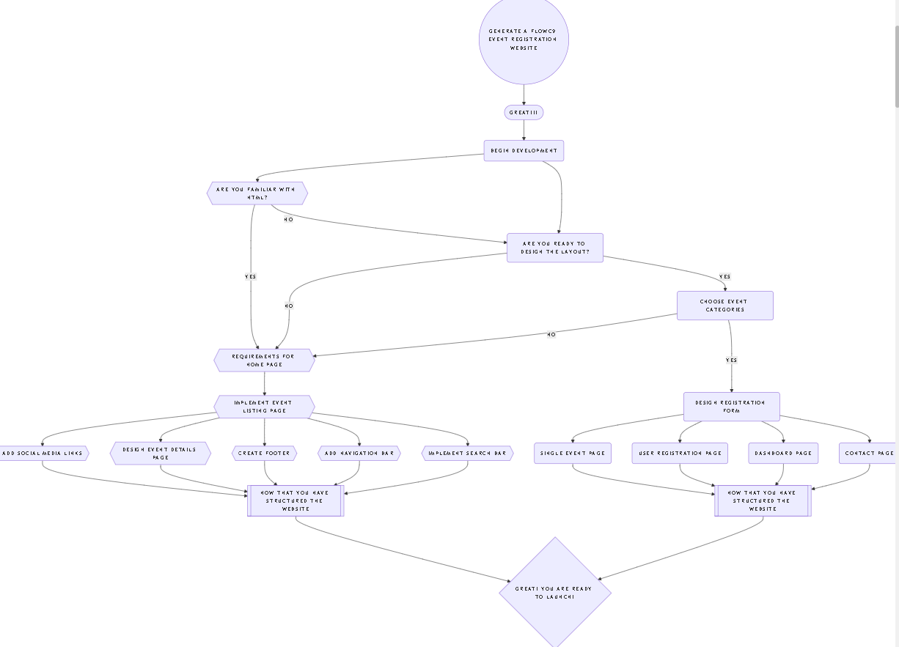

PSEUDOCODE
a. Homepage
DISPLAY hero banner with title and CTA
DISPLAY upcoming events (title, date/time, short description, link)
NAVIGATION links to Events, Register, Contact

b. Event Listing Page
INPUT: user search/filter query
FETCH events from event list
FILTER events based on query
DISPLAY each event with title, date/time, description, and buttons

c. Event Details Page
ON event click:
DISPLAY event details (image/video, description, date/time/location)
SHOW countdown timer to event
SHOW registration form (name, email, phone, ticket type, etc.)
ON form submission:
VALIDATE input fields
IF valid THEN
CONFIRM registration
DISPLAY summary with thank you
ELSE
DISPLAY validation error
ALLOW social media sharing

d. User Registration Page
DISPLAY registration form with input fields
ON submit:
VALIDATE all fields
IF valid THEN
REGISTER user
SHOW confirmation with option to print/email
ADD user to dashboard
ELSE
SHOW error messages

e. Dashboard
FETCH user-registered events
DISPLAY events with details and actions (e.g. cancel, print ticket)

f. Search & Filter
ON search input change OR filter option selected:
FILTER events dynamically using JavaScript/jQuery
UPDATE displayed event list

g. Countdown Timer
SET event start time
CALCULATE time remaining
UPDATE timer every second
IF time = 0 THEN
SHOW message “Event started”

h. Smooth Scrolling & Back-to-Top
ON nav link click:
SCROLL smoothly to section
ON scroll:
IF page Offset > threshold THEN
DISPLAY back-to-top button
ON back-to-top click:
SCROLL to top smoothly

CODES

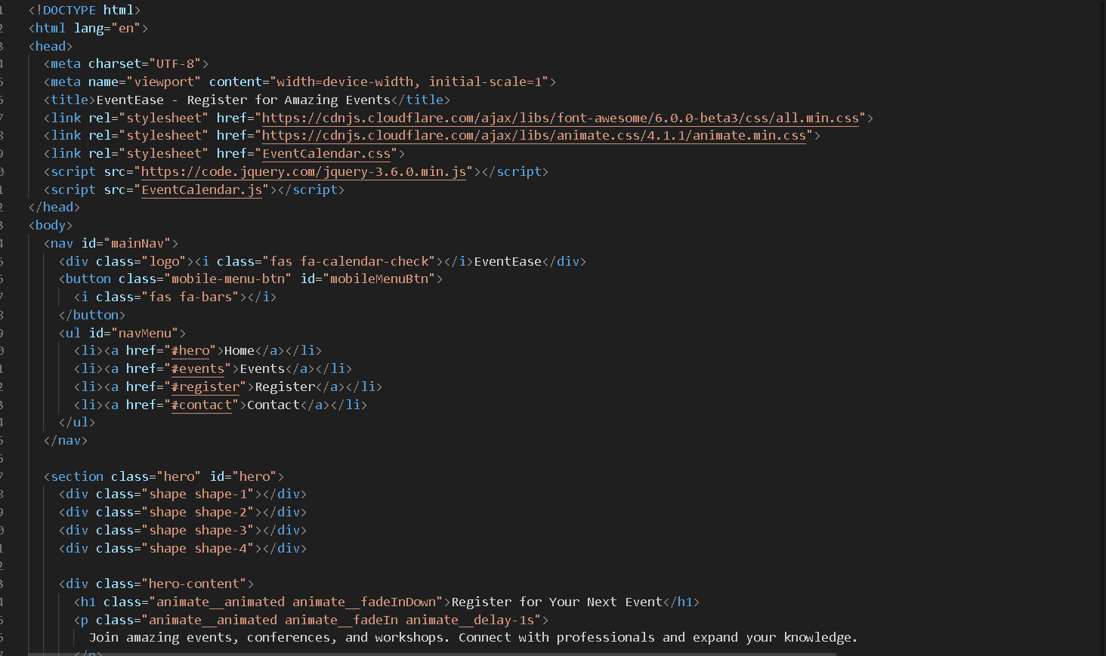
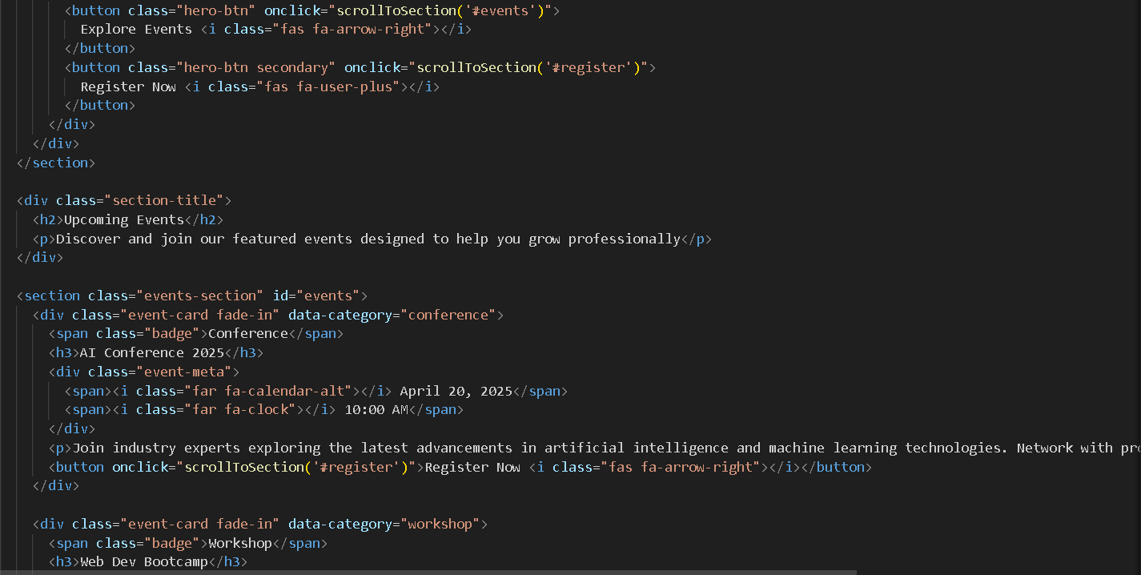

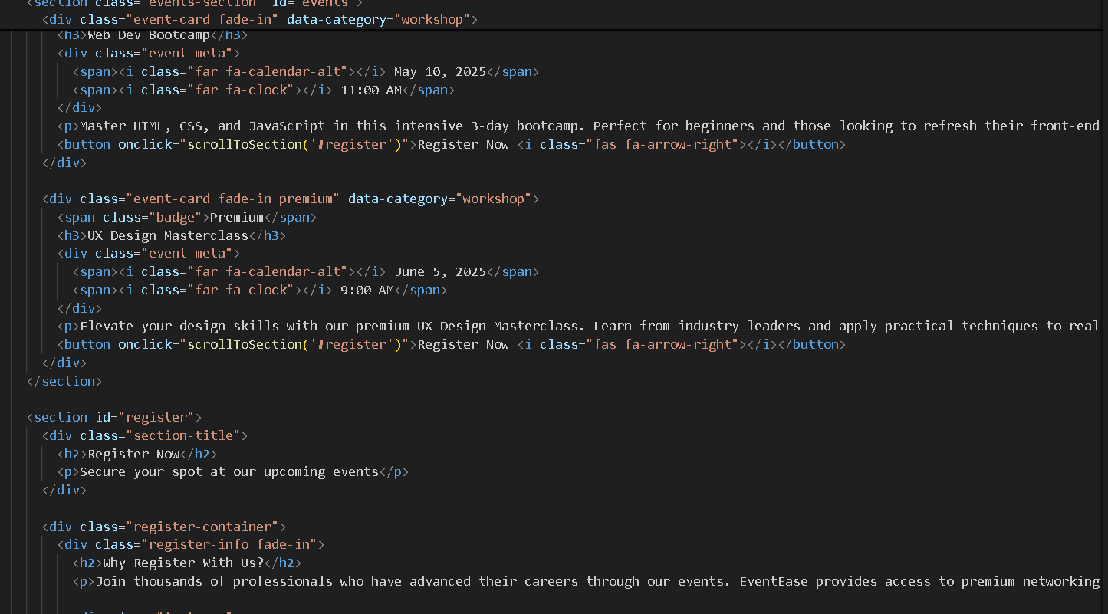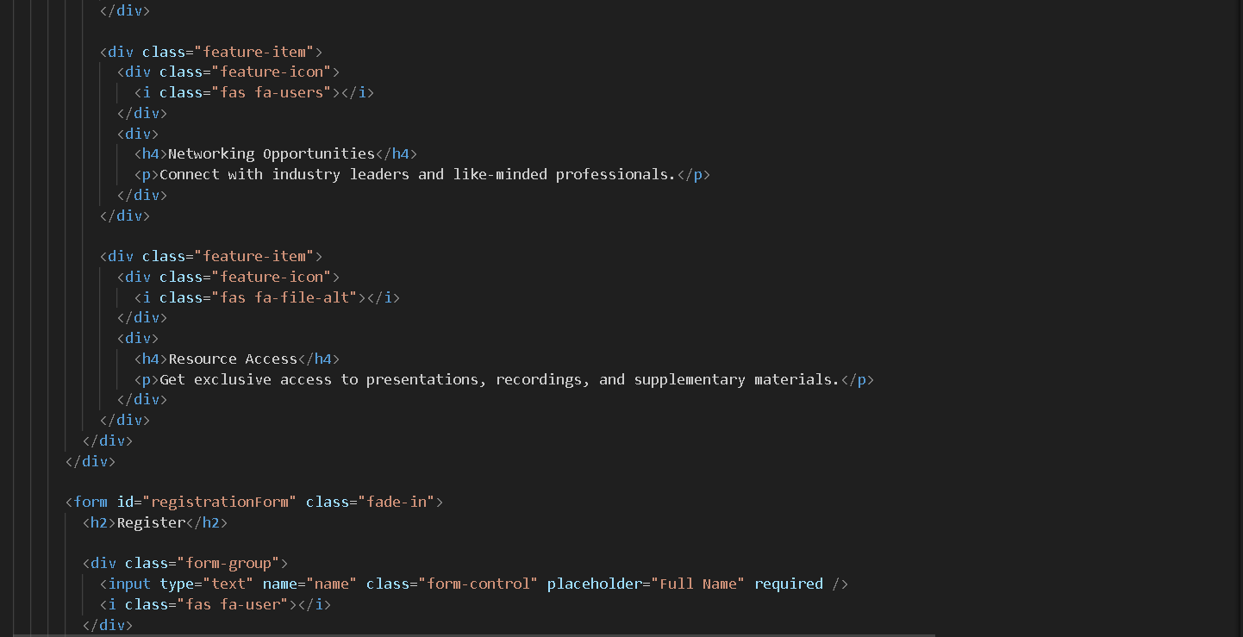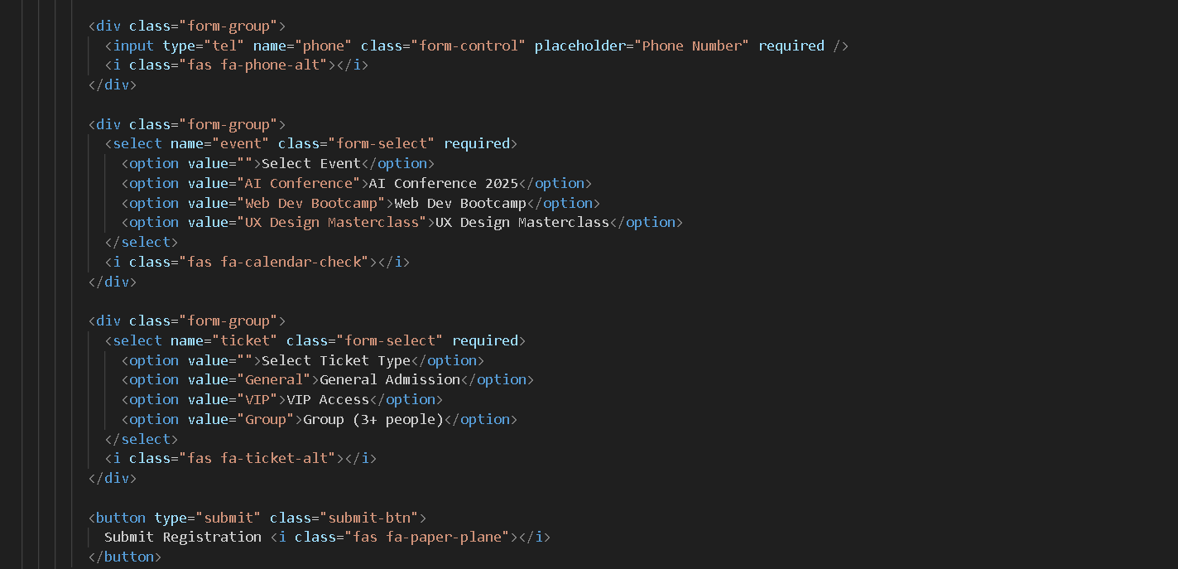
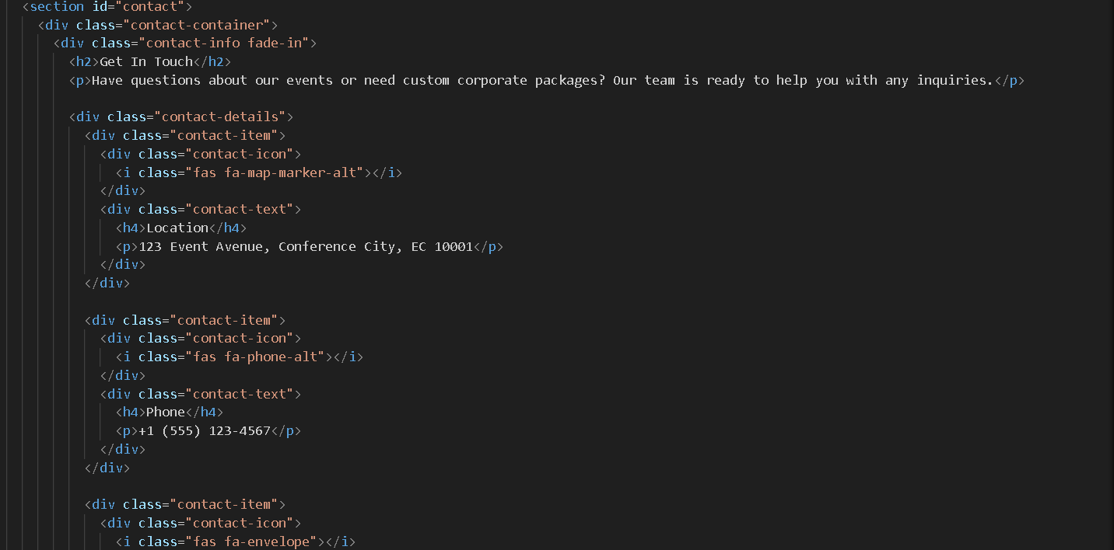
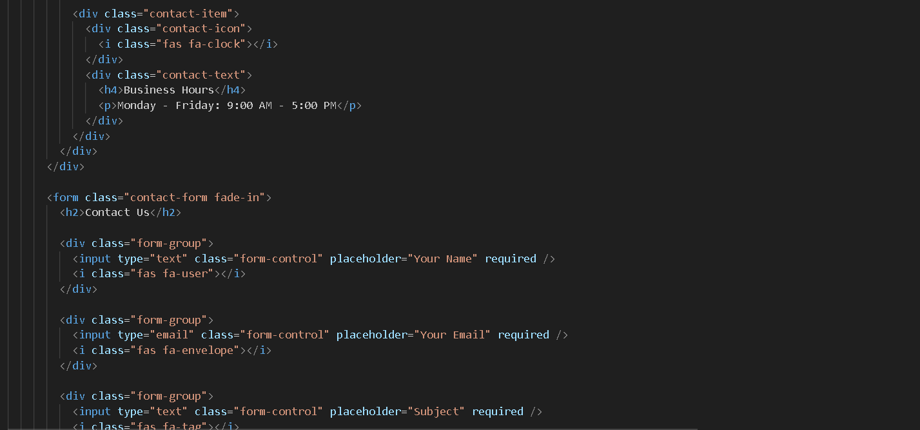

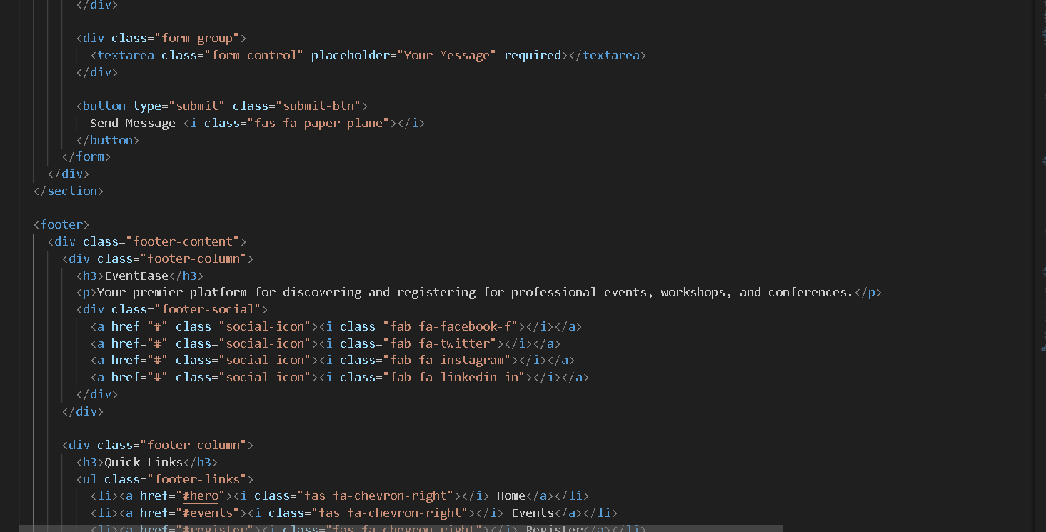

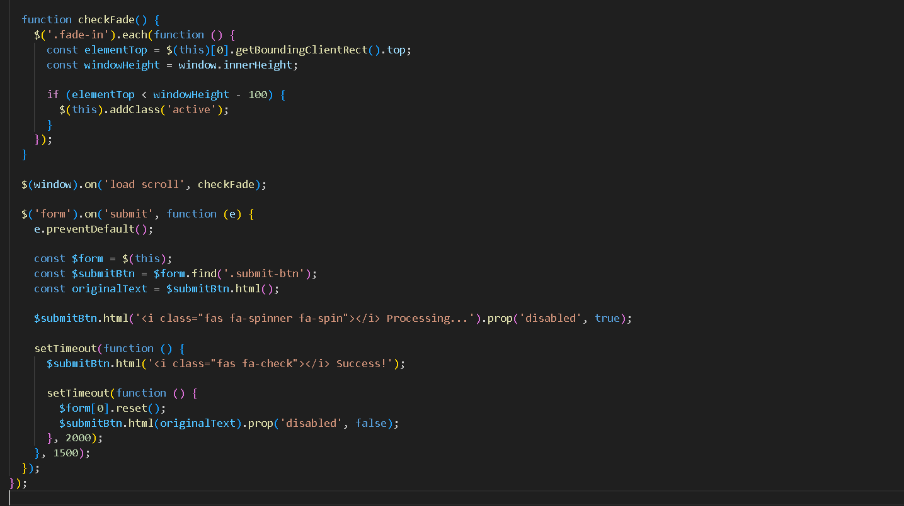

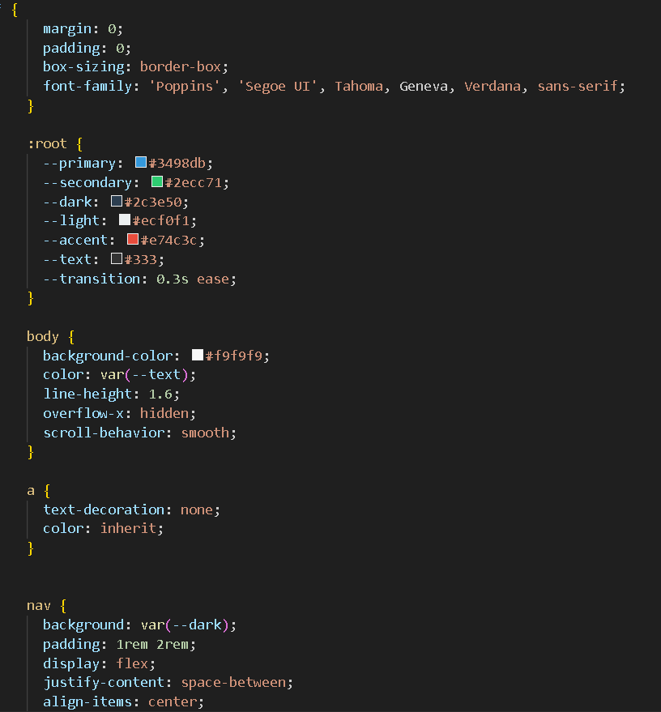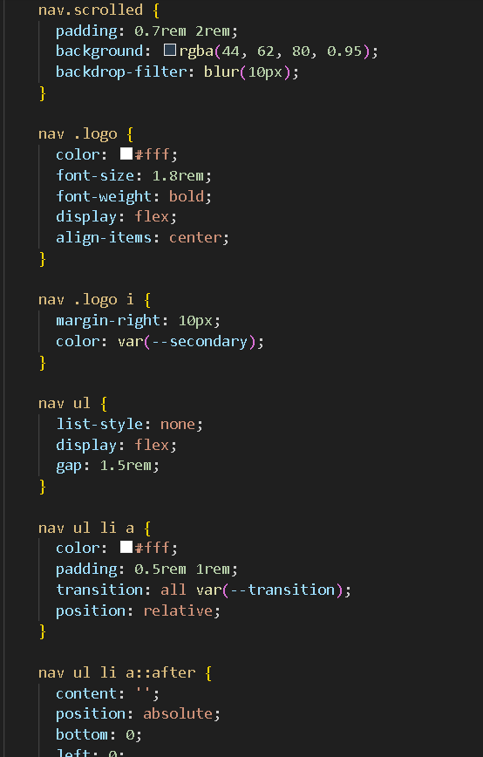

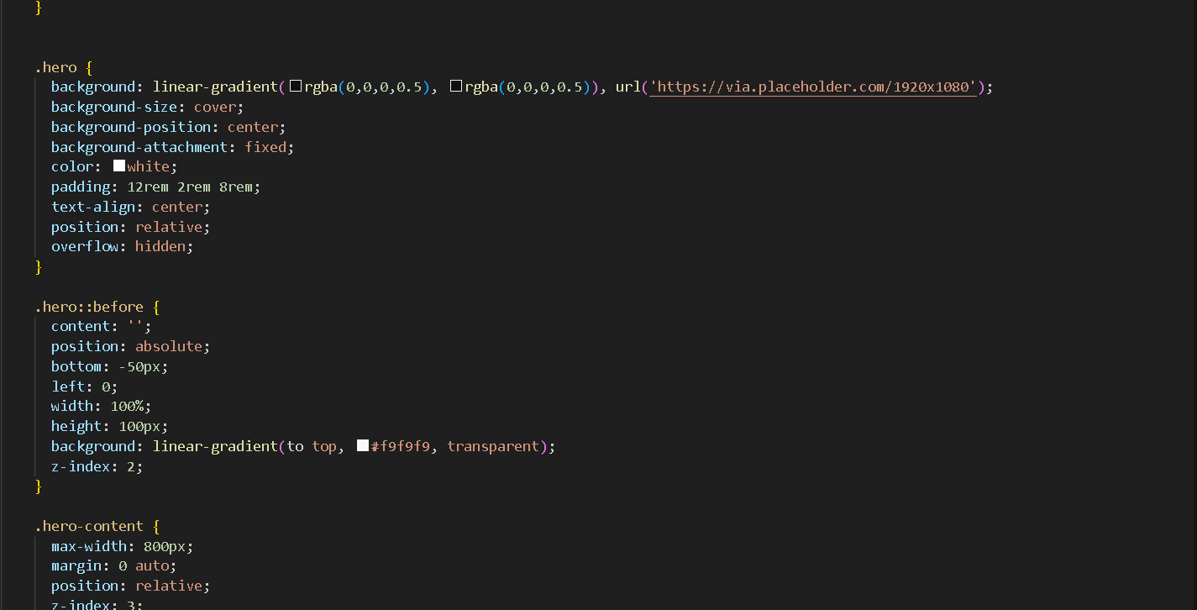

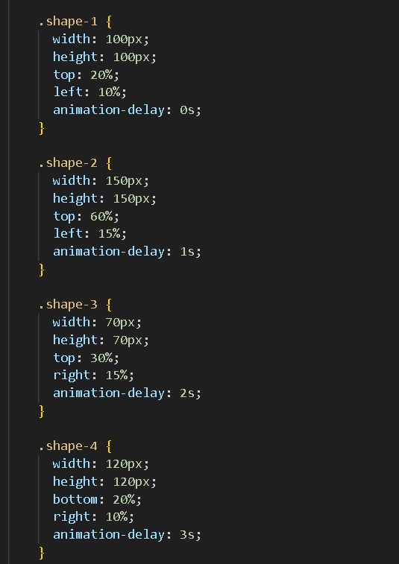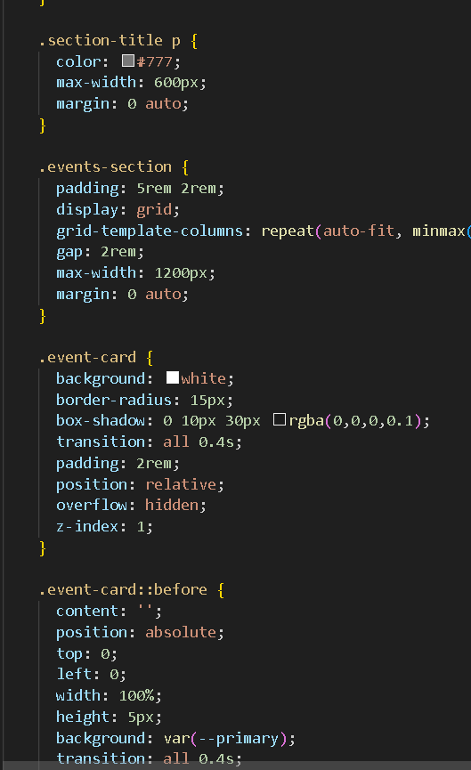

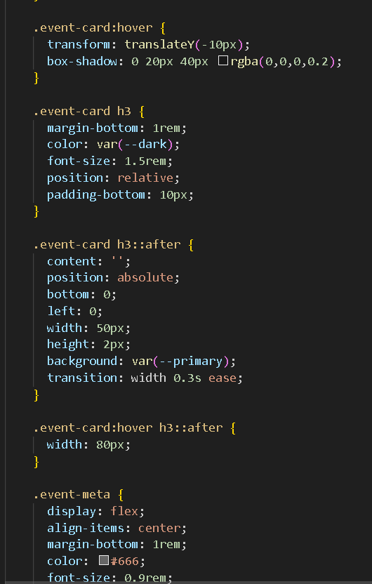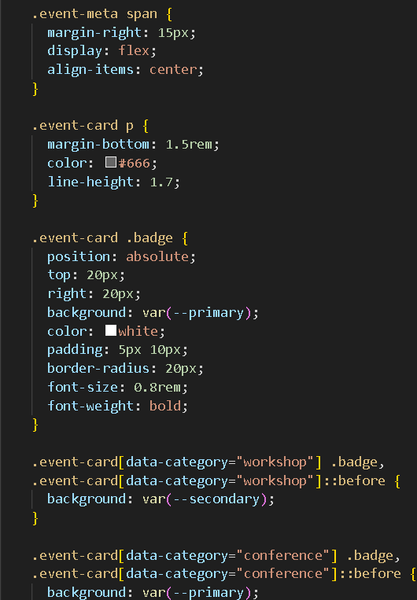

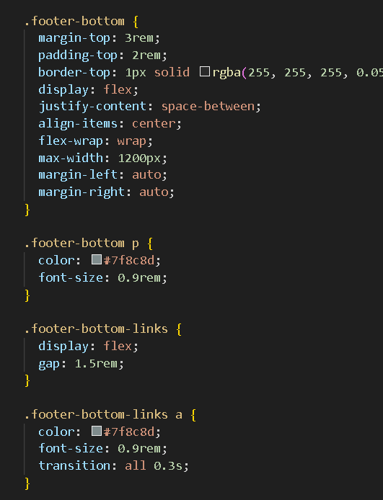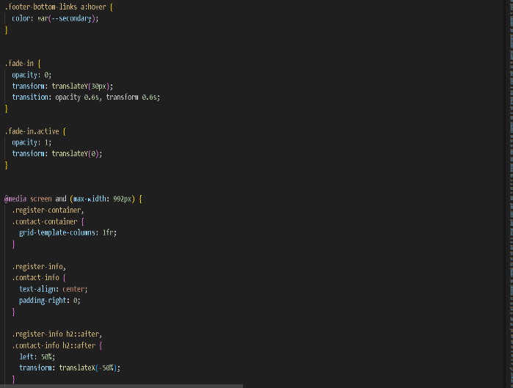

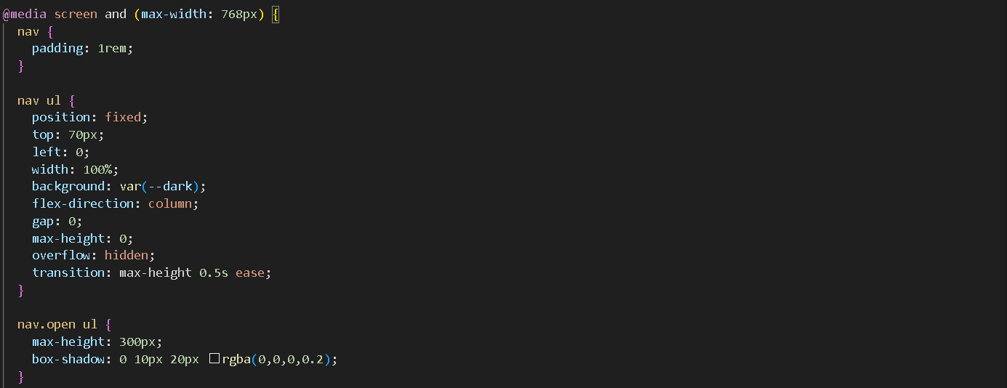

OUTPUTS
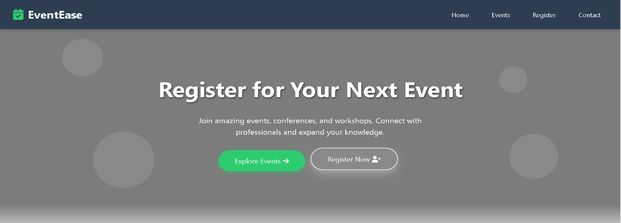

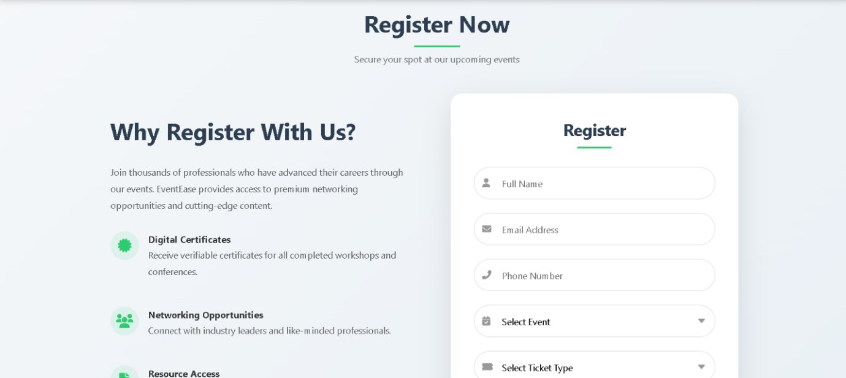
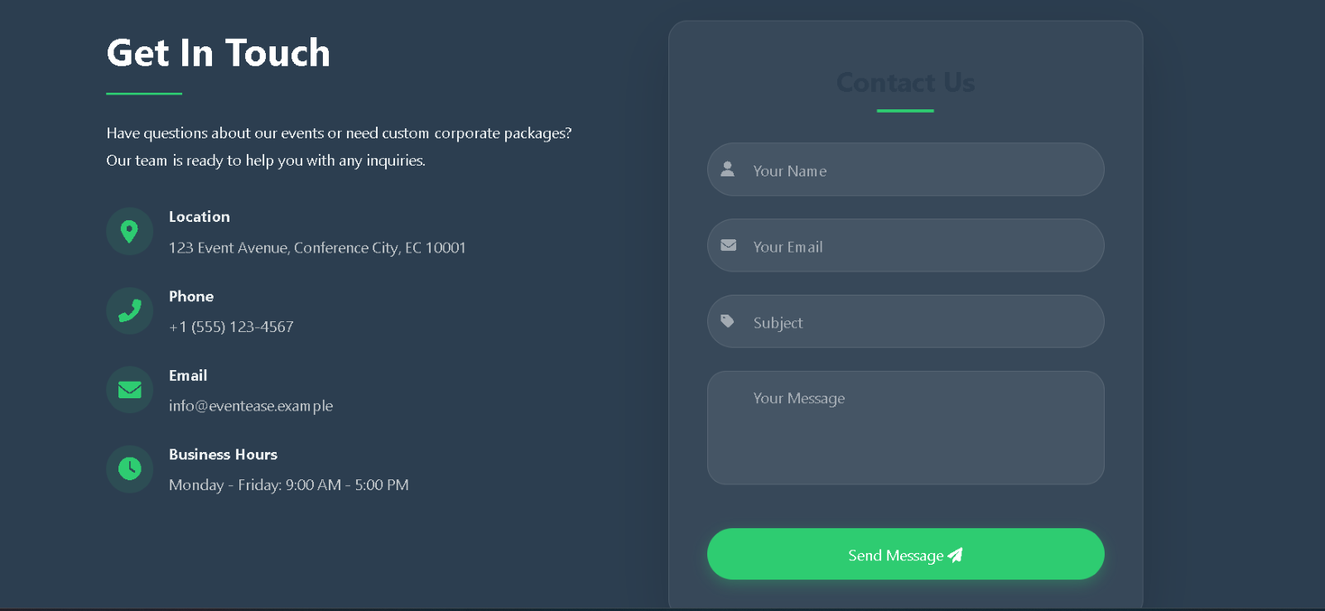

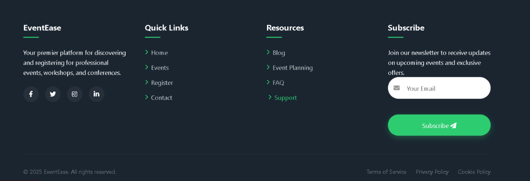

CONCLUSIONS

The Event Registration Website successfully fulfilled its objective of providing users with an intuitive and responsive platform to discover, explore, and register for various events. By integrating modern web technologies like HTML5, CSS3, JavaScript, and jQuery, the system delivers a seamless user experience with features such as real-time search, filtering, countdown timers, and form validation.
The project demonstrates how an event-focused web application can improve user engagement, simplify registration processes, and enhance event visibility. With a clear layout, responsive design, and interactive components, the platform is suitable for a wide range of events, from seminars and workshops to concerts and festivals.
This project not only showcases web development skills but also serves as a scalable foundation for future enhancements, including backend integration, user authentication, payment gateways, and admin dashboards. Overall, it meets its goals in both design and functionality, creating a meaningful and practical solution for event management online.

